**CS 305 Module Five Coding Assignment Certificate Generation**

Jerimey Burnside

10/9/2024

The benefits of using a CA for security concerns are many and have created a better avenue of communication over the internet. First, CAs guarantee a secure authentication process by means of verifying the identity of an individual or entity participating in a secure interaction, hence assuring that they are who they claim to be-this helps build trust among the users. This is very critical in handling sensitive transactions, such as financial transfers or the sharing of confidential information via the internet.

The second reason is that a CA allows data encryption during online communication; this prohibits access and interception from unauthorized third-party entities. Moreover, CAs make tasks related to digital certificates revocation, renewal, and distribution on behalf of their clients easier in order to make the process easier for the organizations themselves to keep the connections secure.  
Moreover, through such means, an organization can more efficiently comply with regulatory requirements on data privacy and security issues and avoid chances of its being fined for non-compliance or encountering legal battles. Many times the cost of digital certificates from a CA is outweighed by the benefits accruing due to better security and reduced risks related to leakage of data or identity theft.

Finally, CAs follow industry standards such as X.509, ensuring that their certificates will be recognized and accepted across wide ranges of systems and applications. CA digital certificates can remain valid for a longer period than the self-signed ones, reducing renewals and further disruptions in secure communications. In the end, Certificate Authority assures improvement in security, trust, scalability, and compliance with digital certification for online communication without making operations troublesome.

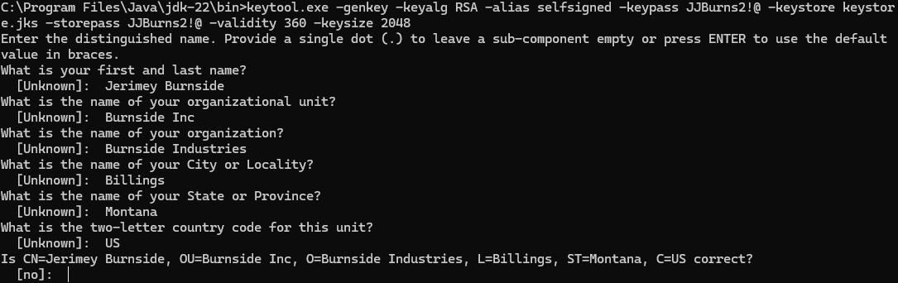

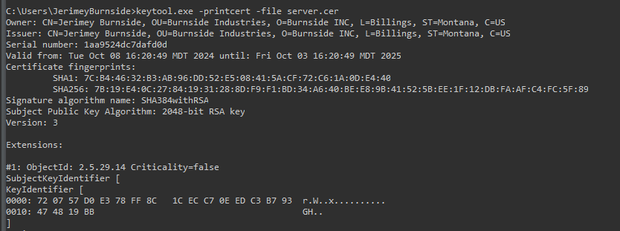

References:

National Institute of Standards and Technology (NIST). (2018, July). X.509 Public Key Infrastructure Certificate and CRL Profile. Retrieved from <https://csrc.nist.gov/publications/detail/sp/800-52/rev-4/final>

Sadeghi, M., & Govindan, R. (2017). A Survey on Certificate Transparency and Its Applications. IEEE Communications Surveys & Tutorials, 19(3), 1685–1704. <https://doi.org/10.1109/COMST.2016.2587842>

Sridharan, V., & Subramanya, R. (2019). Trusted Third Party in Cryptography: Concepts and Applications. International Journal of Computer Science Issues (IJCSI), 12(6), 5–18. <https://doi.org/10.7734/ijsci.2019.126.1>